**SFTP SERVER CONFIGURATION STEPS**

[root@nm ~]# mkdir -p /data/sftp

[root@nm ~]# chmod 701 /data

[root@nm ~]# groupadd sftpusers

[root@nm ~]# useradd -g sftpusers -d /upload -s /sbin/nologin sibasftpuser

[root@nm ~]# cat /etc/passwd | grep -i sibasftpuser

sibasftpuser:x:1000:1000::/upload:/sbin/nologin

[root@nm ~]# cat /etc/passwd | grep -i root

root:x:0:0:root:/root:/bin/bash

operator:x:11:0:operator:/root:/sbin/nologin

dockerroot:x:992:986:Docker User:/var/lib/docker:/sbin/nologin

[root@nm ~]# passwd sibasftpuser

Changing password for user sibasftpuser.

New password:

BAD PASSWORD: The password is shorter than 8 characters

Retype new password:

passwd: all authentication tokens updated successfully.

[root@nm ~]#

[root@nm ~]# mkdir -p /data/sibasftpuser/upload

[root@nm ~]# chown -R root:sftpusers /data/sibasftpuser

[root@nm ~]# chown -R sibasftpuser:sftpusers /data/sibasftpuser/upload

[root@nm ~]# ls -ld /data/

drwx-----x. 4 root root 38 Dec 28 13:23 /data/

[root@nm ~]# ls -ld /data/sibasftpuser/

drwxr-xr-x. 3 root sftpusers 20 Dec 28 13:23 /data/sibasftpuser/

[root@nm ~]# ls -ld /data/sibasftpuser/upload/

drwxr-xr-x. 2 sibasftpuser sftpusers 6 Dec 28 13:23 /data/sibasftpuser/upload/

[root@nm ~]# vim /etc/ssh/sshd_config

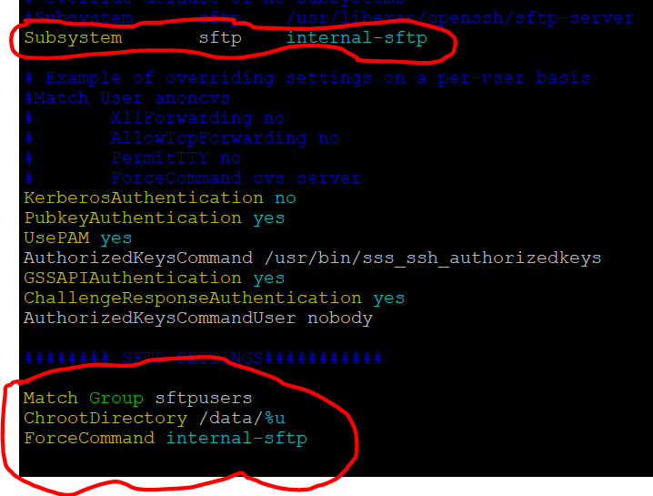

111112222

Match User ftpusers

ForceCommand internal-sftp

PasswordAuthentication yes

ChrootDirectory /data/%u

PermitTunnel no

AllowAgentForwarding no

AllowTcpForwarding no

X11Forwarding no

2233344

[root@nm ~]# systemctl restart sshd

[root@nm ~]# systemctl status sshd

● sshd.service - OpenSSH server daemon

Loaded: loaded (/usr/lib/systemd/system/sshd.service; enabled; vendor preset: enabled)

Active: active (running) since Fri 2018-12-28 13:30:40 EST; 18s ago

Docs: man:sshd(8)

man:sshd_config(5)

Main PID: 4157 (sshd)

CGroup: /system.slice/sshd.service

└─4157 /usr/sbin/sshd -D

Dec 28 13:30:40 nm.xavier01.com systemd[1]: Stopped OpenSSH server daemon.

Dec 28 13:30:40 nm.xavier01.com systemd[1]: Starting OpenSSH server daemon...

Dec 28 13:30:40 nm.xavier01.com sshd[4157]: Server listening on 0.0.0.0 port 22.

Dec 28 13:30:40 nm.xavier01.com sshd[4157]: Server listening on :: port 22.

Dec 28 13:30:40 nm.xavier01.com systemd[1]: Started OpenSSH server daemon.

Hint: Some lines were ellipsized, use -l to show in full.

[root@nm ~]# systemctl status sshd -l

● sshd.service - OpenSSH server daemon

Loaded: loaded (/usr/lib/systemd/system/sshd.service; enabled; vendor preset: enabled)

Active: active (running) since Fri 2018-12-28 13:30:40 EST; 27s ago

Docs: man:sshd(8)

man:sshd_config(5)

Main PID: 4157 (sshd)

CGroup: /system.slice/sshd.service

└─4157 /usr/sbin/sshd -D

Dec 28 13:30:40 nm.xavier01.com systemd[1]: Stopped OpenSSH server daemon.

Dec 28 13:30:40 nm.xavier01.com systemd[1]: Starting OpenSSH server daemon...

Dec 28 13:30:40 nm.xavier01.com sshd[4157]: Server listening on 0.0.0.0 port 22.

Dec 28 13:30:40 nm.xavier01.com sshd[4157]: Server listening on :: port 22.

Dec 28 13:30:40 nm.xavier01.com systemd[1]: Started OpenSSH server daemon.

[root@nm ~]#

[root@nm ~]# sftp

usage: sftp [-1246aCfpqrv] [-B buffer_size] [-b batchfile] [-c cipher]

[-D sftp_server_path] [-F ssh_config] [-i identity_file] [-l limit]

[-o ssh_option] [-P port] [-R num_requests] [-S program]

[-s subsystem | sftp_server] host

sftp [user@]host[:file ...]

sftp [user@]host[:dir[/]]

sftp -b batchfile [user@]host

[root@nm ~]# sftp sibasftpuser@192.168.1.110

The authenticity of host '192.168.1.110 (<no hostip for proxy command>)' can't b e established.

ECDSA key fingerprint is SHA256:pVhwPi46fBGjazzWotlFboS/lkcF6g4GxbsYR/g7kZ8.

ECDSA key fingerprint is MD5:41:de:b2:23:6d:31:12:ce:be:71:0e:84:c4:8e:e0:6e.

Are you sure you want to continue connecting (yes/no)? yes

Warning: Permanently added '192.168.1.110' (ECDSA) to the list of known hosts.

Password:

Connected to 192.168.1.110.

sftp> ?

Available commands:

bye Quit sftp

cd path Change remote directory to 'path'

chgrp grp path Change group of file 'path' to 'grp'

chmod mode path Change permissions of file 'path' to 'mode'

chown own path Change owner of file 'path' to 'own'

df [-hi] [path] Display statistics for current directory or

filesystem containing 'path'

exit Quit sftp

get [-afPpRr] remote [local] Download file

reget [-fPpRr] remote [local] Resume download file

reput [-fPpRr] [local] remote Resume upload file

help Display this help text

lcd path Change local directory to 'path'

lls [ls-options [path]] Display local directory listing

lmkdir path Create local directory

ln [-s] oldpath newpath Link remote file (-s for symlink)

lpwd Print local working directory

ls [-1afhlnrSt] [path] Display remote directory listing

lumask umask Set local umask to 'umask'

mkdir path Create remote directory

progress Toggle display of progress meter

put [-afPpRr] local [remote] Upload file

pwd Display remote working directory

quit Quit sftp

rename oldpath newpath Rename remote file

rm path Delete remote file

rmdir path Remove remote directory

symlink oldpath newpath Symlink remote file

version Show SFTP version

!command Execute 'command' in local shell

! Escape to local shell

? Synonym for help

sftp> ls

sftp> lls

anaconda-ks.cfg sibalv

sftp> cd /var

Couldn't stat remote file: No such file or directory

sftp> pwd

Remote working directory: /upload

sftp> lpwd

Local working directory: /root

sftp> lcd /tmp/

sftp> lpwd

Local working directory: /tmp

sftp> lmkdir testsftp

sftp> lpwd

Local working directory: /tmp

sftp> lls

openldap-tlsmc-certs--5BC1A0212A769016127A58449C1F813044D43EAEF4C1D645825AE6A18EEACFB1 tmp.A4XAvZJdcC tmp.DO1Evt5hGy tmp.mnFpM1Svn0 tmp.rnxFjWmOG8

systemd-private-06646fb6360744fbaaab7ecbdd0dd230-chronyd.service-PZL9lU tmp.a71VDsEWFv tmp.EJ4UwNl7ul tmp.MnHUxIJqIN tmp.sQni9TvjFw

testsftp tmp.bPm03lO4rr tmp.hzlRnOjhxM tmp.oEtiRVTvzQ tmp.TbnhaFm2go

tmp.3xjHSBJ9FI tmp.BQfHfNbjgt tmp.kV5T5crgQA tmp.pxBZEFXz7X tmp.tzLnoEsBCA

tmp.7W7OEt5P9s tmp.CeqVT7e6KG tmp.lKMHPkKZHO tmp.qzY7ba5cFJ tmp.ZvD7YFSNW6

sftp> lcd testsftp/

sftp> pwd

Remote working directory: /upload

sftp> lpwd

Local working directory: /tmp/testsftp

sftp> ltouch sftpfile

Invalid command.

sftp>

sftp> lpwd

Local working directory: /tmp/testsftp

sftp> put sftpfile

Uploading sftpfile to /upload/sftpfile

sftpfile 100% 0 0.0KB/s 00:00

sftp> lcd /

sftp> pwd

Remote working directory: /upload

sftp> lpwd

Local working directory: /

sftp> get sftpfile

Fetching /upload/sftpfile to sftpfile

sftp> !

Create New user for SFTP

[root@nm ~]# mkdir -p /data/siba/{incoming,outgoing}

[root@nm ~]# useradd -g sftpusers -d /incoming -s /sbin/nologin siba

useradd: user 'siba' already exists

[root@nm ~]# userdel -r siba

[root@nm ~]# useradd -g sftpusers -d /incoming -s /sbin/nologin siba

[root@nm ~]# chown -R root:sftpusers /data/siba/

[root@nm ~]# chmod 755 /data/siba/{incoming,outgoing}

[root@nm ~]# chown -R siba:sftpusers /data/siba/{incoming,outgoing}